

**Mitsubishi PS-3 2.5 Ton Semi Inverter**

**Rs. 229,990/-**

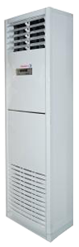

**Product Features**

* Independent Dehumidification
* Low Noise Air Flow System
* Easy Clean Panel
* Remote Control Pocket
* Three Minutes Protection

**Specification**

**Type** Floor Standing AC

**Cooling (Btu/h)** 39000

**Voltage (V)** 220-240

**Power Input (W)** 4500

**EER (Btu/W-h-W/W)** 7.1-3.10